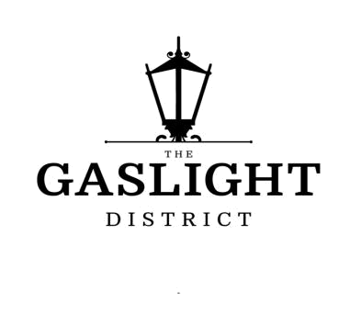

Ignite excitement and discover the Gaslight District. Situated in historic downtown Galt, The Gaslight District will be home to residential , commercial, retail , art, dining, community and culture. Live, Work, learn and play co-exist here to create Something truly spectacular.

Suite Features*

- Quartz countertops with undermount stainless sink and goose neck faucet

- Quality Kitchen cabinetry in stained wood or modern painted finish with designer hardware
- Kitchen Islands (some with build in dining islands-per plan) Some Islands optional
- Smooth finish painted ceilings at 9’ (10’ on Penthouse Level)
- Appliances - stainless-steel fridge, stove, dishwasher, hood range, washer and dryer
- Contemporary 30” Stainless Steel Walk Mount Triangular Range Hood
- Modern Pot Lights in Kitchen


Suite Type

2 Bedrooms & 2 Bathrooms

Deposit Structure

5% upon signing

5% on 90 days

5% in 365 days

5% on occupancy

Telephone : 647-544-7574

Occupancy Date

December 1, 2022.

Parking

Included per Unit


Maintenance Fees

0.35 per square foot for residential suites $15 per parking stall per month

(Heat ,Building manager, Concierge

Building security, Amenity rooms, lobbies utilities
and maintenance

Common areas, parking and property cleaning
and maintenance

Building insurance, Reserve fund contribution Free WIFI in all indoor amenities / common areas)

Email: info@apexaccess.ca

*As per plan specific and/or as provided in Agreement of Purchase and Sale. Availability, promotions and Prices are subject to change without notice. *First Come First Serve Basis. Please see sales representative for details. E. & O.E. May 26, 2021

